

**Customer manual**

**Project**

**“Pondok Daun” website**

Table of Contents

View Website 3

1. View the products. 4

2. Sign up 5

3. Login 6

4. Order the food. 7

5. Book a table online. 8

7.View special items 9

8. Book for catering 9

9. Feedback 10

**View Website**.

First the customer needs to go to the

[www.pondokdaun.net.au](http://www.pondokdaun.net.au)

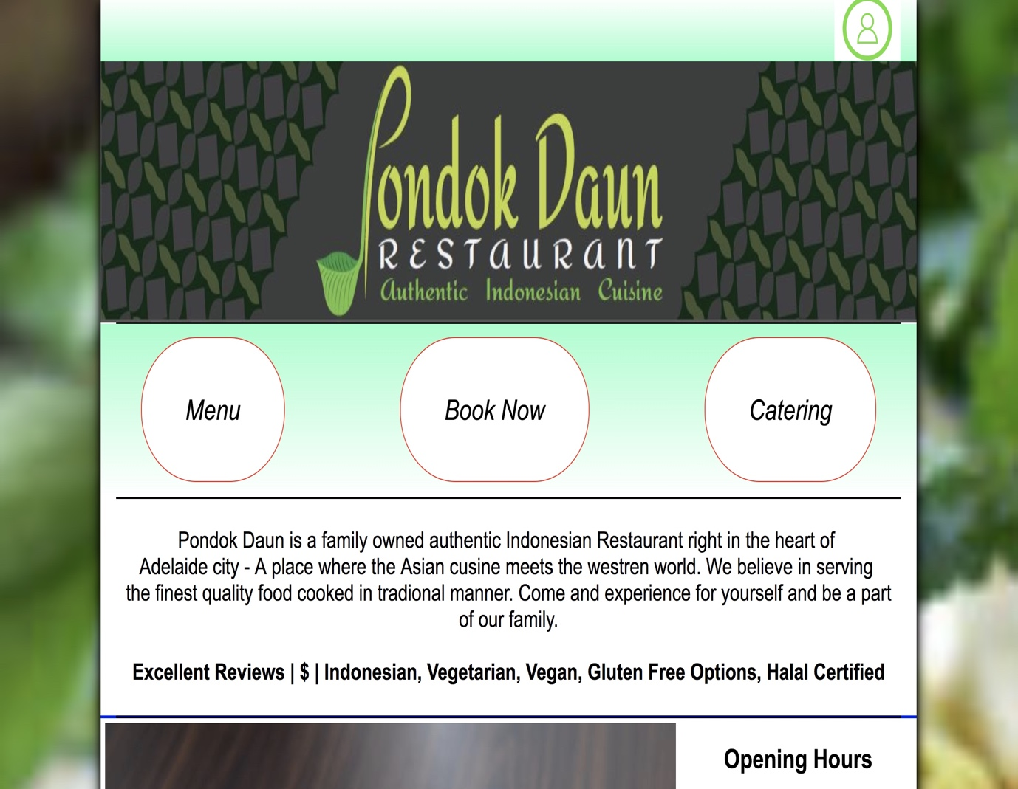

# **View the products.**

Customers can view the products and can choose from different range of food, drinks and entrees.

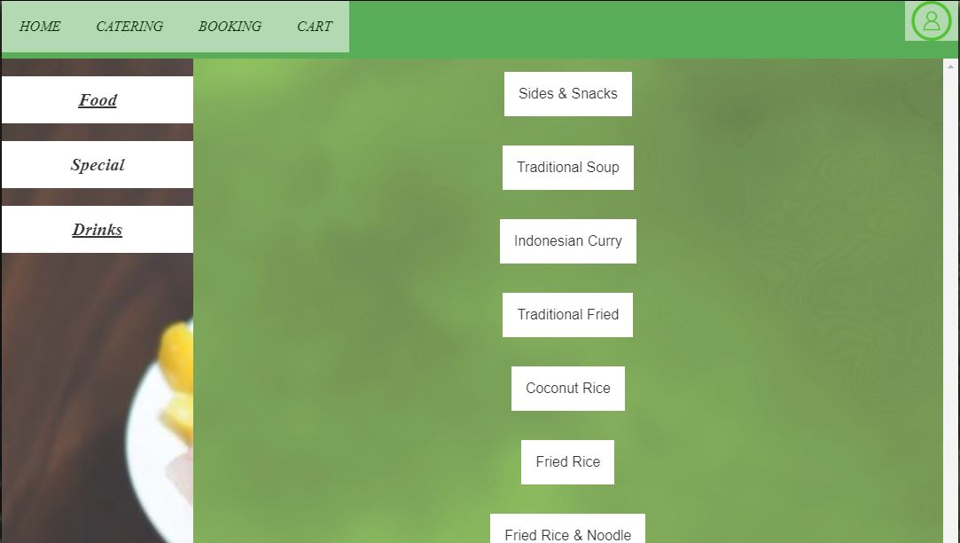

# **Sign up**

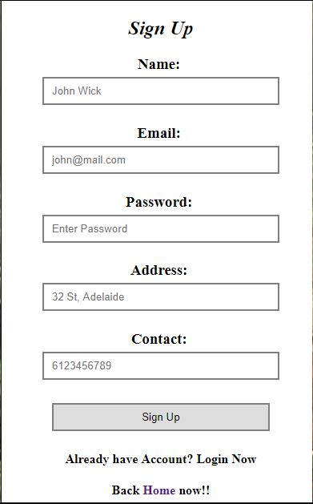

# **Login**

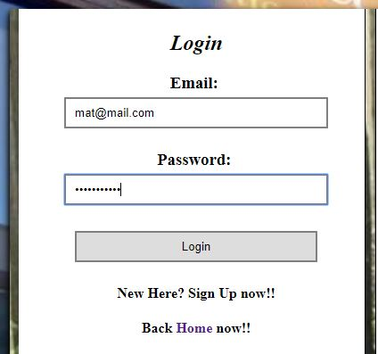

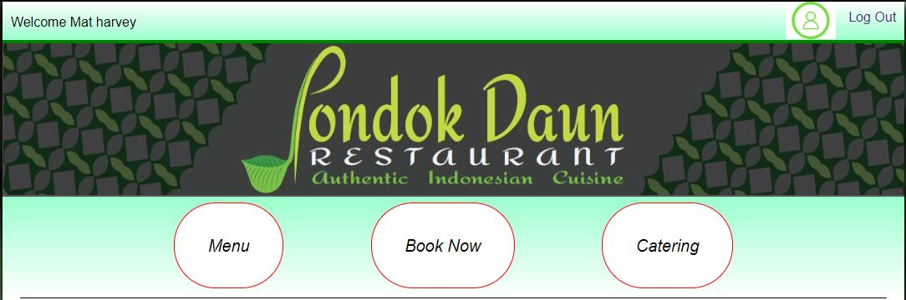

# **Order the food.**

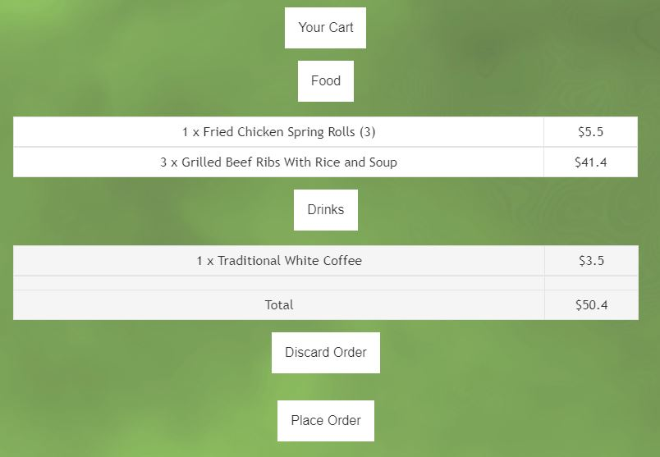

# **Book a table online.**

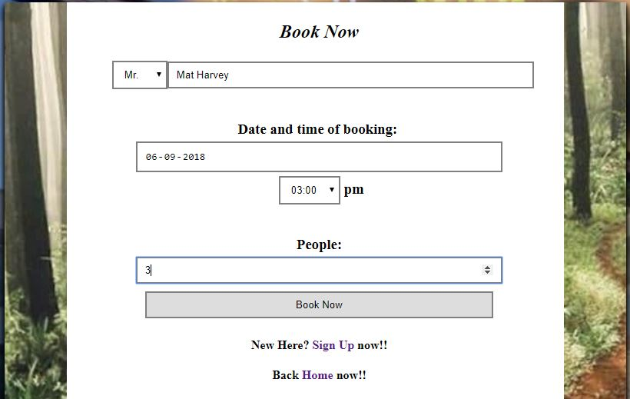

**7.View special items**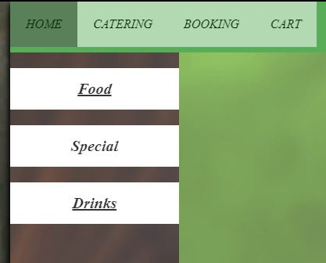

# **Book for catering**

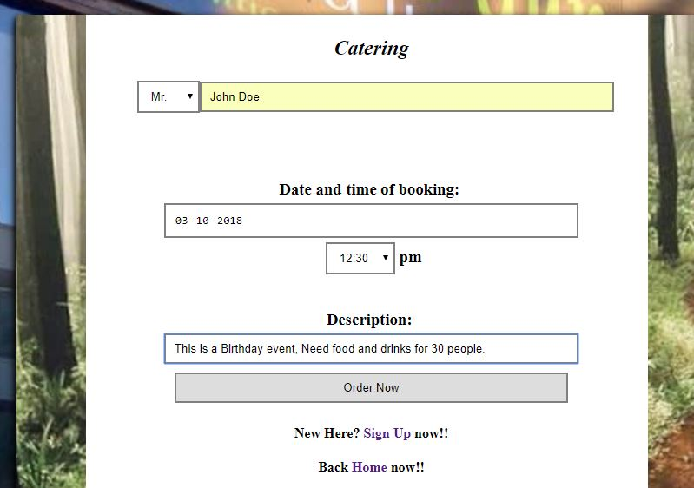

# **Feedback**

